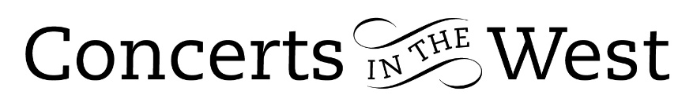

Shiry Rashkovsky and Hiroaki Takenouchi
26-27 June 2026
Bridport Arts Centre, Ilminster Arts Centre, The Dance House Crewkerne

The viola and piano combination of Shiry Rashkovsky and Hiroaki Takenouchi was
a stroke of fortune when the scheduled pianist Lana Suran was unfortunately indisposed just several days before the three concerts. Remarkably, although they were acquainted as friends, Shiry and Hiroaki had never performed together up to this point. Providentially, the first part of their programme was not too musically strenuous and gave the musicians space to acclimatise.

The evening started with the theme of coffee and was a recurring motif throughout. Rashkovsky’s arrangement of Bach’s Coffee Cantata was perhaps befitting to initiate the theme, but the impact was somewhat impaired by the absence of the argument between father and daughter about the relative merits of the coffee-drinking habit, the central reason for Bach’s humorous and rather satirical drama.

There followed two movements from the Suite for viola and orchestra, the Prelude and Carol both calling for deeply sensitive playing and receiving care and insightful playing from Rashkovsky. The gentle pastoral character continued with the Serenade from Frederick Delius’s incidental music to The Story of Hassan and continued with the Lionel Tertis arrangement for viola and piano of the folksong Cherry Ripe.

The closing first half of the programme was jolted into a different musical dimension with Rebecca Clarke’s Passacaglia on an Old English tune. Clarke was herself a renowned violist and composer in first of the twentieth century. This was substantial material that gave the listener a clearer insight into the skill and musicianship of Shiry Rashkovsky, and we were not disappointed. Ably partnered by Hiroaki Takenouchi, Shiry Rashkovsky projected the sturdy structure of the Passacaglia with appropriate passion.

After the interval it was time for further ‘coffee and caffeine’ brought to us by Astor Piazzolla’s ‘Café 1930’ and Freya Waley-Cohen’s Caffeine. The musical contrasts in the former were managed with total assurance and belief. The ‘consumption’ of the caffeine was certainly a necessity for both performers in Philip Glass’s 2008 Sonata for Violin and Piano, in an arrangement by Shiry Rashkovsky, and which concluded the evening programme. This was high wire performing in the circumstances! The work in three untitled movements has all the distinctive hallmarks of Glass’s mature writing. The gorgeous lower viola register tone of the first movement and the slow and romantically expressive of the second were ideal foils for the frenetic energy needed for the third. The outstanding achievement by Rashkovsky and Takenouchi that, though they were continuously within a hair’s breadth of being driven off course by the speed and complexities of the rhythm, there was never hint on their part that they were not in control. It was the audience who experienced the greater tension and mounting anxiety. Such momentum and tension on their part was relieved by furious handclaps and ‘bravos’ at conclusion of the roller coaster experience and in addition the respect so well earned by both performers throughout the evening.

Andrew Maddocks June 2026

