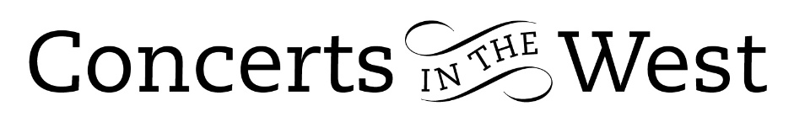
Sara Trickey and Ivana Gavrić
15-16 March 2024
Bridport Arts Centre, Ilminster Arts Centre, The Dance House, Crewkerne

A thoughtful and carefully considered selection of works by music performers is essential for all public concerts. With a violin and piano programme there are enormous riches of repertoire to draw upon. Of course, the programme selection could be performed in chronological order, or it might be determined by some connecting theme. But what sonatas might one choose as being representative of the vast catalogue of music for violin and piano from, say, 1770 to 1940? The permutations might be endless. Sara Trickey (violin) and Ivana Gavrić came up with a fascinating choice: the two-movement E minor K304 Sonata by Mozart; Beethoven’s sublime ‘Spring’ Sonata; the fascinating mixture of varied cultures in Ravel’s G major Sonata; the huge technical and dramatic demands of Poulenc’s Violin Sonata. As if not to overwhelm their audience with a cerebral overload, Trickey and Gavrić played items to lighten the intellectual load by concluding the first half with a Brahms Hungarian Dance and a delightful concert encore, Valse Triste by Franz von Vecsey.

Having chosen a highly attractive selection of works, there is then the important consideration of the programme order. One would naturally have expected the Mozart to be the prime opening gambit. This Sonata is truly a thing of beauty, like a precious stone being turned in the light of the sun with glitter, bathos, and pathos in equal measure. Both the subtlety of Sara Trickey’s technique and the dexterous fingers of Ivana Gavrić’s playing successfully exposed the various shades of the ‘precious stone’ that Mozart had offered them.

But what next in the chosen order? Perhaps the musicians had led us deliberately to a familiar place only to throw the audience a big pebble into its pool of cosiness. Poulenc’s sonata premiered in 1943 by Ginette Neveu and Poulenc, and composed in memory of the Spanish poet Lorca, is a technically demanding dialogue between the two instruments. The writing sometimes gives the impression of a bitter argument and vying for supremacy, then, the next moment, gives way to coalesce and produce sumptuous harmony with melodic surges. Poulenc presumes much of his players to perform ‘the monster’ as he declared his sonata to be. Both players were an equal match for Poulenc’s intimidating ‘monster’!

The posthumous nickname ‘Spring Sonata’ is apt for the F major Violin Sonata written by the 30-year-old Beethoven. Indeed, he emerged into a better light with his Viennese public after the first performance. It is a work full of generous opportunities for its performers to respond to: Beethoven’s embracing lyrical warmth of the sunny first movement; the ‘Adelaide’ love tenderness of the Adagio; the ‘catch-me-if-you-can’ rhythmic ‘dangers’ of the jokey Scherzo; the increasingly spirited variations of the Rondo. Sara Trickey and Ivana Gavrić eased their way through the spectrum of technical demands and expressive range with a mutual confidence that comes from a long-established understanding and rapport between two musical friends.

Maurice Ravel’s second Violin Sonata resonates with many colours that we know so well from his orchestral writing. There are constant echoes of whole-tone scales, Balinese gamelan, the music of Debussy (e.g. La cathédrale engloutie), and Khachaturian’s ‘Sabre Dance’, and an even more overt commitment to another musical style in the third movement, ‘Blues’. This many-hued and variegated work demands a technically secure performing partnership that permits a collaborative freedom of spirit to project this wonderful kaleidoscope of sound to its listeners. Having achieved this, the audience will hopefully rise as one at the end to give a standing ovation. This deservedly happened for an intoxicating performance (and evening!) by Sara Trickey and Ivana Gavrić.
Andrew Maddocks 2024

