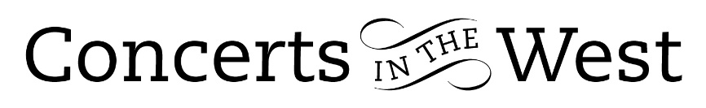
Rosalind Ventris and Richard Uttley
3-4 March 2023
Bridport Arts Centre, Ilminster Arts Centre
The Dance House, Crewkerne

Although there had been a number of works composed by the likes of Vivaldi, Mozart, Berlioz, Robert Schumann and Brahms (two sonatas) featuring the viola in a solo or duet role, it was the 20th century that saw the instrument given far more public prominence through the technical and performing gifts of players like Lionel Tertis and William Primrose and the response from composers such as Walton, Hindemith, Maconchy, Lilian Fuchs and others.

One of the most respected contributions to the viola repertoire is the sonata by Rebecca Clarke. Written in 1919, this work concluded the first half of a delightful programme brought to Concerts in the West by Rosalind Ventris (viola) and the pianist, Richard Uttley. Both musicians are highly regarded and the concert programme of music by Robert Schumann (Märchenbilder), Clara Schumann (Three Romances) and Rachmaninov (an adaption of his G minor Cello Sonata) gave audiences a good understanding as to why they deserve this reputation. Throughout the performances, there was an ease, security and fluidity in their partnership. The deeply romantic programme gave the listeners plenty of opportunity to discover the players’ abilities to cast lyrical spells of fantasy (Märchenbilder), and song-like conversational duets between viola and piano in Clara Schumann’s Romances.

Contrast and a kaleidoscope of sound colours were the central hallmarks of Rebecca Clarke’s Sonata. The young Clarke was herself a violist and her own technical understanding of the instrument’s potential led to a work rich in technical diversity. Her admiration for the prominent French and English composers of the period – Debussy, Ravel, Vaughan Williams, Butterworth – is undoubtedly there in this early work, but there is also a true confidence in her handling of the drama with dark mystery of the third movement unselfconsciously positioned alongside passages resembling bursts of fireworks. These components, the wispish flights of notes between the two instruments in the Vivace, the Celtic character of the viola-only opening to the Adagio demonstrated that Rebecca Clarke had a distinctive voice that would be heard in the fertile catalogue of works that she would go on to write. The fact that these characteristics came across so successfully, was the creative understanding on the part of the musicians that infused the performance.

The transcription of Rachmaninov’s G minor Cello Sonata for viola gives the work an opportunity to be seen in a new light. The piano part reflects much of the symphonic ambition that the composer sought in the Second Piano Concerto written a year earlier. Could the viola hold its own against a bravura piano part when the cello had the advantage of tonal weight? Of the two performances, Ilminster and Crewkerne, the second was more successful in terms of balance. Rosalind Ventris’s instrument sang the tender and nostalgic melodies of the Andante with composure while competing very favourably with the piano in the ‘scatty’ delivery of vigorous rhythms in the Vivace.

Throughout the evening there was a wonderful, shared agreement between Rosalind Ventris and Richard Uttley over tempos, rubatos and tenutos, so essential for a deeply romantic programme.

Naturally, the audience has the last word to show their approbation. At the Crewkerne concert, they were moved immediately to stand as one and salute two very fine musicians who had brought them such a moving experience.

Andrew Maddocks 2023

