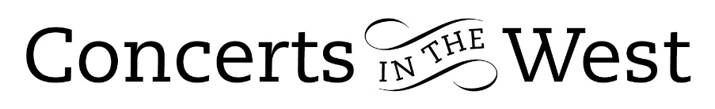

Eloisa-Fleur Thom, Stephen Upshaw, Sam Armstrong
6-7 May 2022
Bridport Arts Centre, Ilminster Arts Centre, The Dance House, Crewkerne

Three extraordinary musicians came together in performances on consecutive days to present a rainbow-assortment of music by composers ranging from Bach (born 1685), Mozart, Schumann, Alban Berg, Debussy, Ysaÿe and Ed Finnis (born 1984).

In her very busy schedule, Eloisa-Fleur Thom (violin) is the Artistic Director and Leader of the 12 Ensemble, London’s un-conducted string orchestra. She and Sam Armstrong (piano) opened the evening concerts with the Mozart’s E minor Sonata. There followed two movement of interplay between the two instruments and music that is at moments, predominantly infused with expectant passion and at others, is simply gloriously melodic. Throughout, both performers committed lots of well-placed energy and a constructive awareness of each other’s role.

Alban Berg’s Opus 1 Piano Sonata came after three years of rigorous instruction with Arnold Schoenberg. The first performance (1911) given in Vienna received a frosty reception, only to be given a warmer understanding at performances several years later. While the single-movement work is harmonically complex, structurally it is in classical sonata form and to audiences today, aurally very accessible. Although one might think the complexity would be challenging for the pianist to play from memory, this was apparently no problem for Sam Armstrong who accomplished the bravura demands with huge skill.

Claude Debussy’s G minor Violin Sonata was first premiered in 1917 when the composer was ill with terminal cancer. The work exudes all that we revere in Debussy’s music: his love of instrumental colour, structural inventiveness and exotic sounds originating from the Far East. Together, Eloisa-Fleur Thom and Sam Armstrong performed with a strong feeling of mutual comprehension for the work and reciprocal sensitivity in their playing.

Stephen Upshaw (viola) was the essential partner to Robert Schumann’s trio, Märchenerzählungen, a four-movement piece of marches that summon up different impressions for the listener. There is no literal textual basis, but each movement conjures up a scene of a fantasy-world beloved of German folk tales.

Before this final work, Stephen Upshaw and Eloisa-Fleur Thom had introduced many of us to the four ‘brothers’ in a work titled, Brother. Ed Finnis, born in 1984 and who is currently a Professor of Composition at the Royal Academy, dedicated the piece to his brothers. Each section sheds an air of open space and freedom even though much of the two part-combination is full of intricate textures. The piece benefitted from a sense of poise and balance achieved by the players.

Elsewhere, the music of J.S. Bach featured in piano transcriptions by Busoni and Petri while several of his two-part Inventions were played by violin and viola. These arrangements gave us yet further sound-prisms on the wonder that is Bach.

Reviewer: Andrew Maddocks – May 2022

