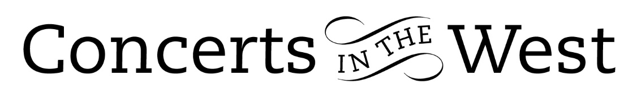

Callum Smart (violin) and Richard Uttley (piano)
15-16 July 2022
Bridport Arts Centre, Ilminster Arts Centre, The Dance House, Crewkerne

What might underpin a successful concert programme? Unity of purpose by the musicians must surely be a top ingredient. With a high order of skill and musicianship in place, along with the components of mutual awareness, respect, and confidence between the performers, then a unity of purpose can be achieved. Throughout their programme one always felt that Callum Smart (violin) and Richard Uttley (piano) were a legitimate voice for the intentions of the composers.

They opened their musical journey with a well-balanced account of the Schubert Duo Sonata in A D574. In the first movement, the jauntiness of Schubert’s piano part and the unruffled melodic line of the violin are sometimes at peace with each other and in other places either coquettish or argumentative. The latter feature is even more prominent in the following Scherzo where sudden contrasts and surprises of rhythm and dynamics suggest a dramatic tussle is being enacted. It is music requiring consummate timing, courage, and athleticism from the performers. This wonderful Sonata established the credentials of Callum Smart and Richard Uttley as top executants with a clear sense of unified purpose.

What followed the Schubert sonata was pure charm. Written in 1853 the Three Romances Op 22 by Clara Schumann are in effect three gorgeous poems without words. The free-flowing lyricism of each Romance gives enormous scope for both players to enjoy some of most engaging music to emanate from Clara Schumann’s pen. Both players were rightly expansive in their delivery of Schumann’s almost endless succession of affectionate, tender, and often playful melodies.

After the delightful and wistful Caprice Viennois composed in 1910 by the early twentieth century virtuoso violinist Fritz Kreisler, we were treated to the Op18 Sonata by Kreisler’s near-contemporary, Richard Strauss. First performed in 1888, this is a work of immense substance and character. By turns joyous, contemplative, and rapturous, it is a high point of true musical Romanticism. Echoes of Brahms’s chamber music are everywhere in its expressive and technical demands. The second movement, Improvisation: Andante cantabile, was one of the most memorable events of the entire concert with moods ranging from the dreamy, the brooding, and rapturous passages, taking it in turns to lure the listener into various stages of nirvana. With the lithe and seductive voice of Callum Smart’s sonorous violin and the thoughtful and responsive playing of Richard Uttley, this was a most persuasive experience. The deceptive opening of the Finale soon gives way to a movement of ever-increasing demands of bravura playing. Callum Smart and Richard Uttley were equal to the task. The final notes brought the audiences to their feet with huge applause and encore-cries that were generously answered with - most appropriately - Brahms’s C minor Scherzo.

The exiting audiences were decidedly vocal in their hope for an early return visit of this compelling duo!

Andrew Maddocks 2022

