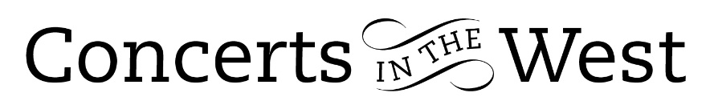

NAOMI BURRELL, GAVIN KIBBLE AND DAVID GERRARD
3-6 November 2022
Minehead Methodist Church, Bridport Arts Centre, Ilminster Arts Centre
The Dance House, Crewkerne, Church of St Lawrence, Upwey

Take healthy amounts of Baroque chamber music in both the Italian and French styles, select examples that attempt to synthesize the two, sprinkle one or two oddities, add plenty of knowledge and skill by three top executants and you have the makings of a great programme for audiences. And so it was, when Naomi Burrell (Violin), Gavin Kibble (viola da gamba) and David Gerrard (harpsichord) toured five Somerset and Dorset venues for Concerts in the West.

The programme ended with Corelli’s ‘La Follia’ Sonata from his Opus 5 set of trio sonatas of 1700, with its contrasting lyrical and darker variations of the La Follia theme, set in sharp contrast to the volcanic ‘madness’ of the faster variations, it was a perfect way of sealing the audience’s approval of the trio’s achievements.

Corelli’s ‘La Follia’ Sonata felt light years away from the first item of the evening, Stradella’s six short movements of his D minor Trio Sonata written several decades earlier. There were traces of a previous era in its construction and music style but also elements of the newer Baroque. The Stradella sonata proved to be a useful key to open an exploration of works by Louis Couperin, Marin Marais, Jacques Morel, Telemann and François Couperin. These more familiar names did not exclude a Suite in E minor by the little-known Jonas Tresor. This was a keyboard suite of three dances ideally suited to the Italian-styled harpsichord played by the excellent David Gerrard. Throughout the concert his part in the continuo playing of the sonatas was apt and cogent. The Tresor Suite was followed by Louis Couperin’s Unmeasured Prelude for keyboard and something of a notational oddity. The pitch is supplied by the composer leaving the performer to determine the rhythms. It was both a looking back to lute tablature but carried hints of what was yet to come in 20th century aleatoric examples of say, John Cage.

Marin Marais was by all accounts a phenomenal viol player and it is not surprising that he composed approximately 600 works for viols. His one-time teacher, the deceased Sainte-Colombe, was the dedicatee of Marais’s Tombeau M. de Sainte-Colombe. This was a moment of real poignancy in the evening with Gavin Kibble’s playing finding the inner depths of Marias’s viol writing through a gamut of darker sounds, a variety of most moving and wonderfully executed tremolos and deriving carefully considered support from David Gerrard’s harpsichord playing.

Georg Telemann was represented by his Trio Sonata in D major, a work full of gorgeous melody. Naomi Burrell’s execution of the expression and ornamentation and careful delight in the nuances of phrasing and dynamics felt palpable throughout. Virtuosity in the faster movements was never allowed to distract the listener’s attention from the trajectory of Telemann’s melodic flight. This work, Jacques Morel’s Chaconne and Corelli’s ‘La Follia’ Sonata gave the trio much to share and demonstrate their appreciation and impact of each other’s contributions, a sign of any good ensemble.

The performance of Neuvième Concert – ‘Ritratto dell’ amore’ (‘Portrait of the Love’) from Les goûts-rèunis (‘The Tastes Reunited’) published in 1724 was part of François Couperin’s intention to show how the rival Italian and French styles might be synthesised. He chose to do this through a mixture of dance and freely-composed character movements. Naomi Burrell, Gavin Kibble and David Gerrard gave a charmingly presented account of the work reflecting the general thoughtfulness they took throughout their programme to connect with the audience.

Andrew Maddocks 2022

