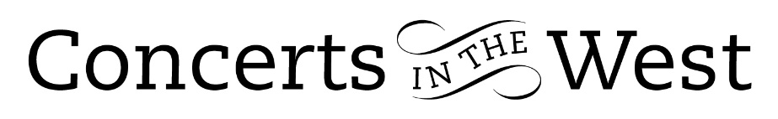

ALASDAIR BEATSON & EUSEBIUS QUARTET
4-5 March 2022
Bridport Arts Centre, Ilminster Arts Centre
The Dance House, Crewkerne

Alasdair Beatson (piano) and Eusebius Quartet brought a fascinating programme of very early 20th century works to the three venues. All four works were written within the space of fifteen years when Europe was being transformed by political conflict and the established music order was being challenged by the likes of Stravinsky, Berg, Webern and Schöenberg. Of the older composers, Fauré had completed his D minor Piano Quintet in 1906 and Elgar, his E minor String Quartet, in 1919. Both composers had long established reputations and their individual composing styles were well understood. But the young Erich Korngold was far less predictable. The precocious nine-year-old boy was proclaimed a genius by none other than Gustav Mahler and Richard Strauss endorsed this slightly later. By the age of 24 and the completion of Piano Quintet in E major, Korngold was an acknowledged success.

Recordings made at the venues revealed performers with the skill to reveal the essence of each of the composers. Quintessential Elgar inhabits every phrase and note of the String Quartet Op 83. The first movement asks the players to have a clear sense of collective forward momentum as they individually swoop and dive through the realm of counterpoint writing. Eusebius met this challenge with poise and self-assurance. Elgar’s wife, Alice, described the central movement as ‘captured sunshine’ and so, the Eusebius’s performance proved. The soaring energy of the final movement leads to an inescapable unity of the four instrumental parts. The playing was testament to the understanding and rapport that Eusebius brought to this performance of the Elgar.

Eusebius and Alasdair Beatson recorded the Korngold Piano Quintet Op 15 on the SOMM label, released in 2021. The consensus of thought and approach was apparent from the outset of the dramatic and turbulent first movement. The music is daring and demanding, perhaps provocative to listeners not aware of Korngold’s harmonic and rhythmic style. The expression of the slow movement is sometimes tender but invariably intense. Throughout this work there is always authenticity, honesty and huge imagination in Korngold’s writing and instrumentation. He did not attempt to follow latest fashions or an established older generation of composers. The performance was played with great understanding, passion and respect for a work richly deserving our admiration.

By the time of the premiere of his Opus 89 Piano Quartet in 1906, Fauré was sixty-one. Would there be anything new that he could stylistically add to his much-respected catalogue? Fauré did not disappoint, and the first performance correctly deserved its acclamation. The performance by Beatson and Eusebius was similarly and appropriately received by its listeners. Alasdair Beatson is known for his fondness and intimate knowledge of Fauré’s chamber and solo piano music, and the Eusebius Quartet demonstrably identified with this passion in their performance of the work.

Andrew Maddocks March 2022
www.eusebiusquartet.com www.alasdairbeatson.com

