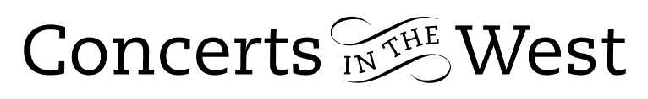

FENELLA HUMPHREYS, CARA BERRIDGE & LIBBY BURGESS
2-3 September 2022
Bridport Arts Centre
Ilminster Arts Centre
The Dance House, Crewkerne

This was a mini-tour of three musicians who had performed with each other in other groupings and venues but never together as a trio. Fenella Humphreys (violin), Cara Berridge (cello) and Libby Burgess (piano) presented an engaging programme of works by two composers in the later stage of their output and compositions by two composers at the start of their careers.

The 15-year-old Schubert’s one-movement Sonatensatz began the evening, a piece demonstrating an extraordinary understanding of structure, style and instruments gained from his awareness of the chamber music of Haydn and Mozart and laying down markers of his own later compositions. The performance by Humphreys, Berridge and Burgess was well-considered and beautifully judged, with precision, weight and balance being the hallmarks.

The trio then moved to an early piece by the much-respected Cheryl Frances-Hoad. Her My Fleeting Angel, based on characters in Sylvia Plath’s 1964 short story The Wishing Box, dates from 2006. The contrast of Harold and Agnes’s dream experiences becomes the source of severe frustration and despair for the insomniac Agnes. Some of the power and drama was rather understated and a more dynamic tempo would have provided a greater electrical punch to the Allegro spiritoso. On the other hand, the rhythm appeared to be secure and precise. Frances-Hoad’s challenges her performers in all sorts of technical ways. On this occasion, one felt that the melodic duet of the cello harmonics and the senza vibrato violin of the opening Larghetto did not sparkle successfully to suggest Harold’s vivid experiences in his fantasy.

Fauré’s D minor Piano Trio written in 1922-23, shortly before his death, brought us back to more familiar fare. It is a work drawing on a cornucopia of melody and has a harmonic underlay of enormous elasticity, stretching forward to continuously redefine the tonal centre of gravity. The players demonstrated their joint ability to gradate their energy towards climatic points as in the first movement. This co-ordination of control and timing led to a beautiful ending to the Andantino. Throughout, the performers showed an awareness and understanding of their individual roles within the ensemble.

The so-called ‘Dumky’ Piano Trio by Czech composer Antonin Dvorák is well-placed to hold the listener’s attention. It is full of contrasts, a work that moves suddenly from great passion and folk-dance exuberance to lyricism and nostalgia. In Fenella Humphreys there was a violinist who could sweep us into the village square for a Slavic folk dance; in Cara Berridge there was a cellist who provided moments of pure tonal poetry and nuanced dynamics; in Libby Burgess there was a pianist who commanded the piano to sing lone melodic lines with a true cantabile.

The performers are to be thanked for their helpful, informative and appropriate introductions to the works in the programme.
Andrew Maddocks 2022

