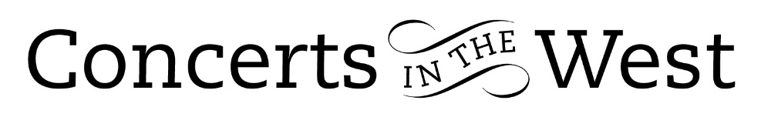

PELLEAS ENSEMBLE
31 March – 3 April 2022
Minehead Methodist Church, Bridport Arts Centre, Ilminster Arts Centre
The Dance House, Crewkerne, Church of St Roch, Pendomer

In a manner of speaking the Pelléas Ensemble was born in 1915 with the completion by Claude Debussy of his Sonata for flute, viola and harp, a work of nobility, coherence and warmth. At the time there was only one minor piece for this instrumentation. Debussy’s Sonata paved the way for numerous trios by various composers throughout the next hundred years. The combination gained popularity partly due to its unique timbre: with its bowed and pizzicato abilities, the viola bridges the gap between the sostenuto and mellifluous core of the flute and the plucked harp tone colours.

In Pelléas Ensemble’s programme Debussy’s Sonata was cleverly prefaced by his solo flute piece Syrinx written two years earlier. Syrinx is a musical soliloquy that gives the performer room for spontaneity within a carefully structured framework. Henry Roberts judged the rubato possibilities wonderfully, always allowing the expressive elements to sound natural. The quiet note-held endings had the feeling of an unbroken gossamer strand, such was his serene control. Syrinx faded into an undisturbed silence before the Pastorale movement of the Sonata emerged to take its hold on our senses – brilliantly done! The work has thematic ideas that are transformed and reworked throughout, giving an amazing feeling of cohesion. The Finale presents the performers dramatic opportunities for interplay between harp (Anne Denholm), viola (Luba Tunnicliffe) and flute (Henry Roberts). Pelléas embraced the moment with enthusiasm and style.

The only other piece in this programme originally written for flute, viola and harp was Between Earth and Sea by Sally Beamish and premiered in 1997. With a poignant dedication to children who died in infancy, the music is a Celtic lament based on the mournful call of the redshank, a bird associated with the transition from life to death. Beamish, a composer with immense awareness of instrumental tone colours, continuously reshapes the four-note redshank call throughout, sometimes allowing anger to surface before the journey from earth to sea is complete. Pelléas judged the various changes of emotional intensity with skill. The intimacy of the music was enhanced by the closeness of the players and listeners at several of the venues.

Four hundred years separated the selected songs written by John Dowland and Rebecca Clarke and cleverly arranged for the three instruments by Luba Tunnicliffe. It is important to remember that the songs only exist because of the inspiration felt by the composers for the text, e.g., Yeats: The Cloths of Heaven, Blake: Infant Joy, Houseman: Eight O’Clock). The verbal presentation of the text would have benefitted from a clearer delivery and one conveying more of the poetry’s meaning.

Successful arrangements of music originally intended for other groupings has the advantage of bringing more music to live audiences. So how successful would Gilad Cohen’s arrangements be in reducing Prokofiev’s enormous Romeo and Juliet orchestral ballet score to flute, viola and harp? Pelléas selected four excerpts. The technical demands placed upon the performers is huge, especially on the harpist, who is asked to pick up much of the lower orchestral pitch range with the rhythmic and harmonic drive in the faster movements. The viola is asked to take on the role of the string sections while the flute covers the woodwind aspects. The fun-and-games between Juliet and her nurse was wonderfully carried out by Henry Roberts and Luba Tunnicliffe. The Cohen arrangement for Prokofiev’s street brawl music is stunning and Pelléas’s playing, even more so.

Andrew Maddocks 2022

