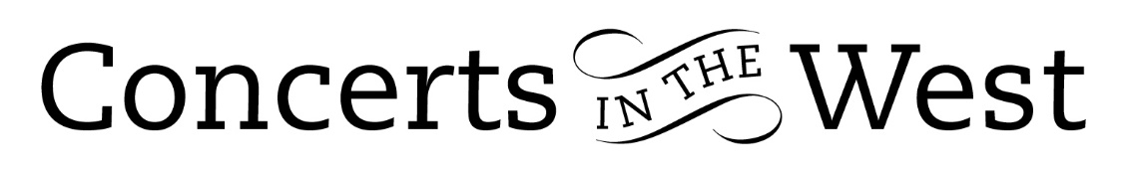
EMMA HALNAN & EBLANA STRING TRIO
30 September – 3 October 2021
Bishop’s Hull Hub, Bridport and Ilminster Arts Centres
The Dance House, Crewkerne, Upwey Church, Dorset

The latest tour promoted by Concerts in the West brought together the excellent flautist, Emma Halnan and the very accomplished Eblana String Trio to perform an imaginative and cleverly devised programme. The content ranged from one of Mozart’s more familiar flute quartets, C major K 285b from 1777/8 to a piece titled A Blackbird Sang by the composer David Matthews written to a commission in 2013. Beethoven’s D major String Serenade and a Quartet in C minor by the lesser-known Italian contemporary Giovanni Viotti provided late Classical period contributions. Gerald Finzi’s Prelude and Fugue for string trio written in 1938, is a piece that embraces archaic structures with Finzi’s very personal harmonic modernity. The music of the Brazilian composer Heitor Villa Lobos completed the programme with his very evocative Assobio a Jato (‘The Jet Whistle’) written in 1950 and posing huge technical demands on the two players, Emma Halnan (flute) and Peggy Nolan (cello).

This ambitious menu of items provided the musicians with a set of challenges to their mental and physical stamina as they faced five performances in four consecutive days. However, Eblana are seasoned performers of long acquaintance dating back to their days as students at the RNCM and are individuals with formidable technical abilities. Likewise, the 2010 winner of the woodwind category of BBC Young Musician, Emma Halnan, is the complete award-winning musician with solo, chamber music, recording, radio and orchestral experience. All four players were more than equal to their five-concert challenge and helpfully this intelligent programme gave each player an item to ‘sit out’.

Beyond their qualities of good ensemble playing, each player was provided with a piece that gave them the limelight: the Beethoven trio gave a very welcome spotlight on the viola playing of Lucy Nolan; Villa Lobos gave tremendous scope for Peggy Nolan (cello) and Emma Halnan; the Viotti quartet demonstrated the poise and appropriate phrasing of Jonathan Martindale’s artful violin playing.

David Matthews was present at Upwey to introduce and hear the performance of his work, A Blackbird Sang. The piece was inspired by the four notes he once heard a blackbird sing at dawn. Those notes were a trigger for a work of masterly skill and inventiveness by one of the UK’s most prolific composers.

It is the stated mission of Concerts in the West to bring the best of a younger generation of musicians to new audiences across the south-west. By providing ‘first-time’ concerts at Bishop’s Hull near Taunton and Upwey near Weymouth as well as more familiar venues in between, Concerts in The West is fulfilling an important cultural mission to our larger community.

Andrew Maddocks – October 2021
www.concertsinthewest.org www.emmahalnan.co.uk www.eblanastringtrio.com

