

CATHERINE MADDOCKS
8 Morgans Rise – Bishops Hull – Taunton – Somerset – TA1 5HW
01823 252658 - 07776 995789
director@concertsinthewest.org
Charity no. 1139301
www.concertsinthewest.org

Dear Supporter,

You have been in receipt of information from us, largely by email but perhaps also by post in recent years.

You may know that The Data Protection Act of 1998 has been updated to become The General Data Protection Regulation (GDPR) which comes into force on 25 May this year and all organisations holding data about individuals are required to update procedures and inform those on whom they hold data.

We now write to say that we propose no changes at all to the way we hold and use your data, as our existing processes comply fully with the new requirements and would like to assume that we may continue to use your data unless you say otherwise.

We attach a formal `Privacy Policy` for Concerts in the West for your information. This explains more fully what we do and don`t do.

We hope we may continue to rely on your support for Concerts in the West.

With best wishes,

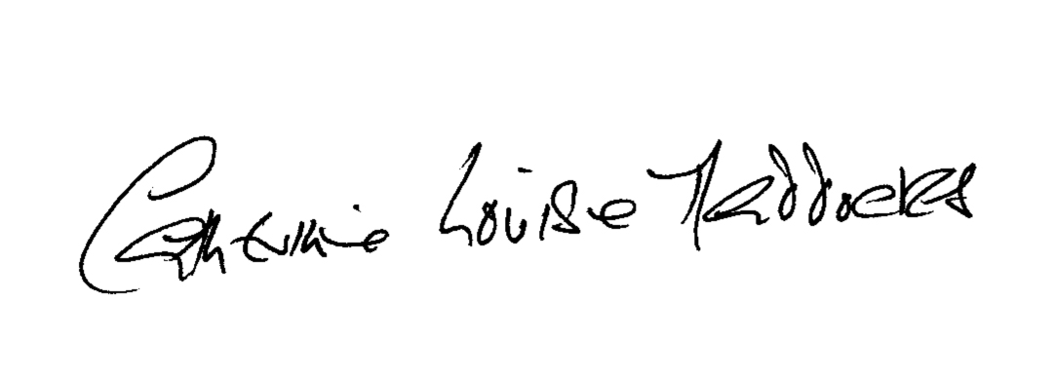

Catherine Maddocks
Director

