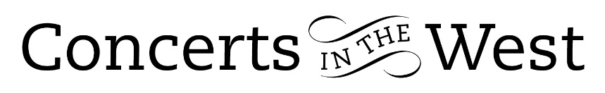

CONSONE QUARTET
31 October-2 November 2019
Taunton Creative Innovation Centre (Somerset)
Bridport Arts Centre (Dorset)
Ilminster Arts Centre (Somerset)
Crewkerne Dance House (Somerset)

A review of the Crewkerne concert

A programme of string quartets composed by a 14 year old Mendelssohn, a 15 year old Schubert, a relatively mature 29 year old Mozart and a rarely heard two-movement example by Luigi Boccherini, a contemporary of Mozart, gave the capacity audience at Crewkerne’s Dance House an insight into the considerable qualities of the Consone Quartet. As the evening progressed it became understandable what has led the BBC to award Consone the status of New Generation Artists for 2019-2021. In addition to the unquestionable technical accomplishments of each musician, there is a clarity of purpose and thought as to the fundamentals and ideals of quartet playing. Consone exude confidence, calmness and poise in their delivery. There is ease and humility in their manner and a strong sense of respect for the music. These qualities were caught and palpably felt and expressed collectively by applause and individually in remarks made by listeners on exiting.

The short two-movement E minor quartet from Boccherini’s set of 1781 proved an ideal ‘overture’ for the more substantial E flat quartet from Mozart’s set of six quartets composed 1784-1785. The latter illustrated in abundance Consone’s complementary balance of tone, dynamics and phrasing. With the second movement’s hymnodic mood and sinuous lines, Consone gave us an impression of time standing still. Agata Daraskaite’s confident and assured violin playing was a notable contribution. The Menuetto e Trio movement is full of life, humour imbued with a strong folk-dance element. Its lilt and chattering quavers suggesting a lively conversation between friends. The Allegro vivace finale demonstrated Consone’s clear consensus over the various tempo changes and rubatos.

The early Schubert C major Quartet was one of a number of pieces he wrote for intimate domestic performance. The Consone ‘family’ brought intimacy to their performance. The second movement has the nature of a later Schubert melancholic song, beautifully played by Agata Daraskaite and with a suave but suitably sensitive accompaniment from her friends, Magdalena Loth-Hill, Elitsa Bogdanova and George Ross. The spirited final movement, full of vigour and presaging Schubert’s later orchestral energy, served to illustrate another dimension to Consone’s appeal, namely, that no room is given for individual self-indulgencies. Their physical and cerebral input at such moments is balanced and directed towards the music and each other.

Very appropriately for music of the late 18th and early 19th centuries, Consone Quartet use
gut strings, Classical period bows and well-judged vibrato. This produced a warm and tonal homogeny while permitting phrasing of a suitably graceful kind for the song-like melodic structures of Mozart and Schubert. At the same time there was a singular clarity emanating from each instrument that in the Bachian-styled fugue of Mendelssohn’s E flat Quartet lent a further sense of participatory balance that is such a feature of Consone’s identity. Being the final sounds of a very pleasurable evening, the Fuga encapsulated so much of the attractive performing qualities that the Consone Quartet possesses.

www.consonequartet.com
www.concertsinthewest.org

© Andrew Maddocks 2019

