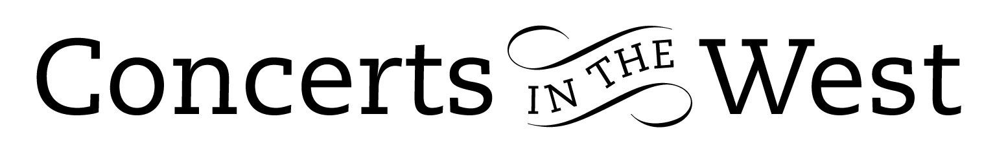

ELISSA CASSINI (violin) and ALASDAIR BEATSON (piano)

2-4 May 2019
Wellhayes Vineyard (Wiveliscombe), Bridport Arts Centre (Dorset)
Ilminster Arts Centre (Somerset), Centre for Young Musicians Taunton,
The Dance House, Crewkerne

Probably most professional violin and piano duets will present performances of the Fauré Opus 13 and Brahms Opus 108 violin sonata that are note-accurate and have well-considered musical thinking. There are some performers who add a full physical and powerful dimension to their playing that transport the works to higher level. Elissa Cassini (violin) and Alasdair Beatson (piano) came with distinguishing features with a palpable impact on the music during their recent tour sponsored by Concerts in the West. With the addition of Schubert’s G minor Violin Sonata, Cassini and Beatson drew their listeners into the various, often contrasting, moods and musical statements with a magnetism stemming from the players conviction in their musical decisions and performing skills to realise their intentions.

The Schubert sonata is often referred to as a sonatina on account of its scale, but like much of his music, size is no impediment to Schubert on the impact of his ideas. The first movement opens with a serious martial fanfare-like statement but within 20-bars Schubert has taken us to a sunny song-like melody in a major key. Thence forward, the sonata develops into a tussle of musical ideas often lying somewhere between a quarrel and an uneasy friendship. Cassini and Beatson’s dynamic input energised the intensity of this dualism.

Fauré’s two violin sonatas gave a serious boost to the efforts of the Société Nationale de Musique founded in 1871 to establish a distinctive French style in this genre. In the first sonata, Fauré follows the conventional four-movement structure. However the musical content is classic Fauré with long, broad sweeps of colourful harmonies often rushing forward with the violin flourishing on the crest of chromatic tidal-waves during the opening movement and gossamer–like melodic tenderness in the following Andante. The Allegro vivo demands enormous alacrity, humour and verve and Cassini and Beatson had those attributes in plenty.

Brahms’s final violin sonata written between 1886-1888 when the composer was at the height of his powers is a tour de force of musical coherence and compositional ‘know-how’. Often rhythmically complex and pianistically challenging, the work always feels logical but never predictable. As a twenty-minute piece it requires enormous concentration from the musicians. They have to negotiate four very distinctive musical climates from the rather disorientating cross-rhythms of the opening Allegro to the stunning lyricism of the Andante, the fast playful-duo of the Un poco presto and the appassionato of the finale. Concerts in the West asks its visitors to give four concerts in three days. With such a physically and mentally demanding programme and a well-executed workshop for sixty young musicians on Saturday morning, the schedule was a tall challenge. Cassini – excellent violin intonation - and Beatson’s performing abilities, focus and stamina were more than a match and they added a George Enescu encore for good measure!

www.alasdairbeatson.com www.elissacassini.com

Andrew Maddocks 2019

