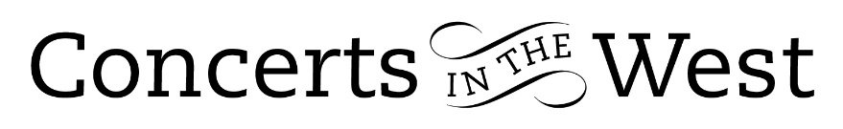
ChamberMusicBox
2-4 June 2023
Bridport Arts Centre, Ilminster Arts Centre, The Dance House, Crewkerne
St Laurence Church Upwey

ChamberMusicBox was the brainchild of two of the four musicians who formed part of the latest tour-group in Concerts in the West’s current 2023 season. The violinist, Yuri Kalnits and cellist, Julia Morneweg founded ChamberMusicBox in 2016 with the intention of building a series of concerts with like-minded friends with exceptional abilities. Four seasons later, more than 50 musicians from 20 different countries, and over 60 chamber works later, the Covid-19 pandemic struck. By using great ingenuity ChamberMusicBox survived and is now beginning to spread its wings and to perform in the UK and internationally with a series of extremely well-known names.

Yuri and Julia brought Matthew Kettle (viola) and Philip Howarth (oboist) to the four venues with a programme of string trios and oboe quartets. First up in the programme was Schubert’s one-movement trio in B flat major. This trio was left incomplete by Schubert. It has a wonderful sense of open-hearted intimacy inviting three friends to a carefully crafted exchange of respectful conversation. The attentive and courteous rapport between the three musicians was palpable.

The final work of the programme was the ever-fabulous Oboe Quartet in F major by Mozart. Friedrich Ramm for whom Mozart wrote the quartet was apparently a remarkable player with the formidable Mannheim Court Orchestra. Mozart was already acquainted with Ramm’s playing, his executant skill, the tone of his instrument – which Mozart described as ‘delightfully pure’ – and wrote the oboe part accordingly: Philip Howarth also played accordingly. The performance of the Adagio movement was a joy to experience.

The programme contained youthful examples of composers in the early stages of their development. Kodaly’s Intermezzo, Elgar’s Andante and Allegro for oboe quartet and Suite for String Trio by Sibelius, all reveal evidence of the later characteristics of each composer. This is particularly true of Britten’s Phantasy Quartet Op. 2. Dedicated to the renowned oboist Léon Goossens. The confident student at the Royal College of Music in 1932 was not prepared to follow the conventional prescriptions of the professors but to assert his own approach to composition. The structure and his ideas, such as the opening passage growing out of a dark silence – wonderfully executed by the players – foretell someone with new ideas and a fresh approach to creativity.

Malcolm Arnold was an experienced orchestral player and composer of many works at the time he wrote his Oboe Quartet (1957). His lifetime output was to be vast, but this work is quintessential to Arnold the person. A first movement full of life and invention; a second full of anxiety and gathering gloom; the last, full of joie de vivre and ensemble challenges. All the tests encountered were soundly met by each member of ChamberMusicBox.

Programming a collection of disparate pieces is never easy, the sequence and order are important to get right, and this important aspect was achieved with success.

Andrew Maddocks 2023

