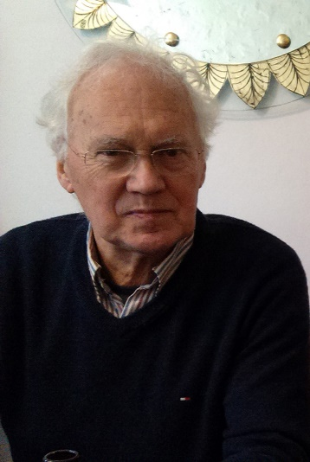

**Anthony Pither (1940-2022)**

Anthony was born in Yeovil, near where his father ran the furniture business that bore the family name. Anthony developed exceptional musical ability, taking piano lessons from the age of four. His talent led to a first-class degree from Birmingham University, where he won a first-year scholarship to spend a summer in Vienna and Salzburg immersing himself in music, and as a student-conductor put on concerts, including ‘The Bartered Bride’, starring the soprano Dame Josephine Barstow, then an English student.

Anthony became a music teacher at Bilborough Grammar School in Nottingham, notably organising a trip to Coventry Cathedral to see the second performance of Britten’s War Requiem, the impact of which remained in his memory.

Following a period as Head of Music at Bishop Otter College, Chichester, where he was at the forefront of new creative teaching methods for music, Anthony became Music Organiser at Aston University’s Centre for the Arts. Composition was a constant thread in Anthony’s life; his symphony was performed in 1980 by the Birmingham Philharmonic at the Town Hall.

In 1984, Anthony became a music lecturer at Leicester University, and later Music Director, organising concerts, conducting student groups, composing, and coordinating music across the university. He worked with the Helix Ensemble who premiered some of his works, and oversaw the success of the Lindsay Quartet series and concerts by the Archduke Piano Trio. Anthony’s many compositions from this period included concertos for violin, for piano and for horn.

After his retirement to Ilminster in 2007, Anthony joined the organisation of Concerts in the West. He also became Chairman of the Ilminster Arts Centre, overseeing volunteers with a calm, gentle hand.

Anthony will be remembered for the significant accomplishments of his musical career as well as his immense generosity and kindness to those with whom he worked.   
December 2022